C PROJECT EXPLANATION
Name: Phạm Thanh Nhân
Student ID: 1951083
- Introduction:
  - The C program:
This program uses dynamic stack to manage list of students. The program also supports following function:
- POP
- PUSH
- SEACH ID
- SEARCH NAME
- PEEK
- EMPTY
  - Interface:
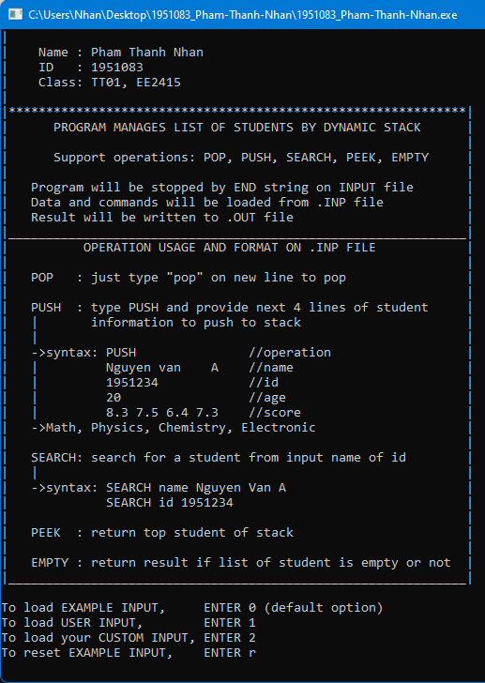
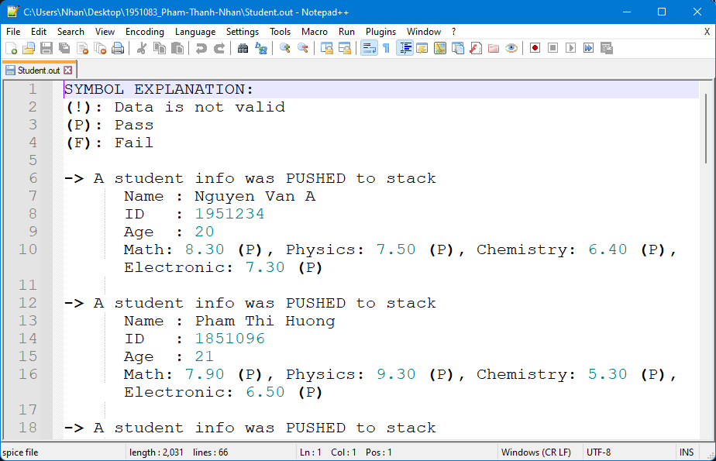
- Usage:
  - Input console option: 0, 1, 2, r
    - 0: load EXAMPLE INPUT to the program and is the default option
    - 1: load USER INPUT (or custom input) to the program
    - 2: load CUSTOM INPUT support different input file location
Please provide path to file without “”.
EX: D:\ABC\Mg\this_input.txt
    - r: reset EXAMPLE INPUT to default
  - After input option, the program will load input file to process
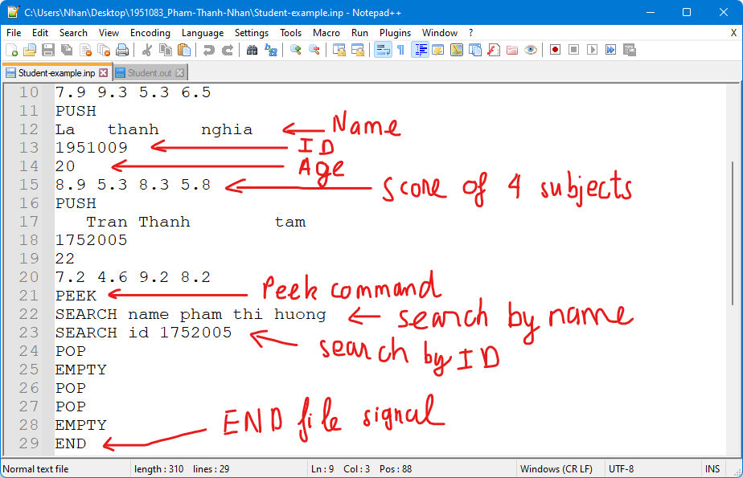
  - The output
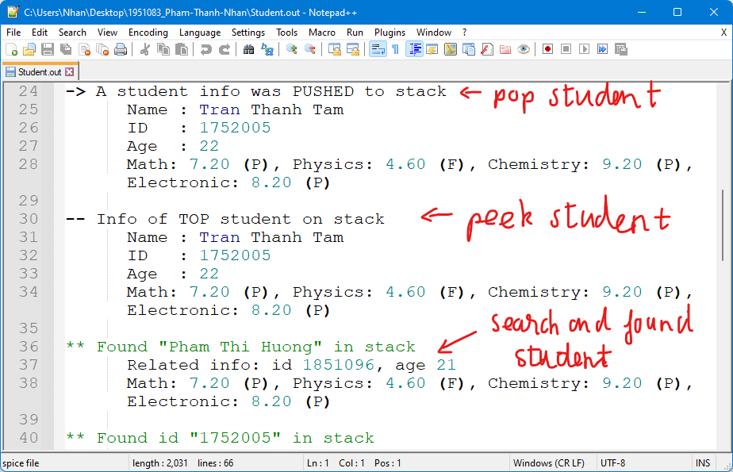
- Code explanation:
  - File processing:
void process_file()
{
printf("\n -> Your choice: ");
scanf("%c", &choice); fgets(tmp, sizeof(tmp), stdin);
if(choice == '1') strcpy(tmp, USER_INPUT);
else if(choice == '2')
{
printf("\nExample of custom input name: Abc.txt or D:\\Test\\myinput.txt\n\n");
do
{
printf(" -> Enter your custom input name or location: ");
fgets(custom_input, sizeof(custom_input), stdin);
custom_input[strcspn(custom_input, "\n")] = 0;
strcpy(tmp, custom_input);
if(strcmp(tmp, "r")==0) goto reset_input;
fi = fopen(tmp, "r");
if(fi == NULL)
{
printf("\n !! Cannot find your custom input file.\n");
printf(" Please check your spelling and directory.\n");
printf(" You can enter \"r\" to load default file.\n\n\n");
}
} while(fi == NULL);

}
else if(choice == 'r' || choice == 'R')
{
reset_input:
regenerate_example_input();
printf("\n -> EXAMPLE INPUT file regenerated! EXAMPLE INPUT was loaded by default.\n");
strcpy(tmp, EXAMPLE_INPUT);
}
else
{
if(choice != '0') printf("\n -> Invalid input! EXAMPLE INPUT was loaded by default.\n");
strcpy(tmp, EXAMPLE_INPUT);
}
//---------------------------------------------------------------------------------------------
fi = fopen(tmp, "r");
if(fi == NULL)
{
printf("\n -> No INPUT file was found!");
strcpy(tmp, USER_INPUT);
fi = fopen(tmp, "w");
fclose(fi);
regenerate_example_input();
printf("\n -> An EXAMPLE INPUT was generated and loaded by default.\n");
strcpy(tmp, EXAMPLE_INPUT);
fi = fopen(tmp, "r");
}
printf("_______________________________________________________________\n");
printf("\nProgram is reading from \"%s\" file.\n", tmp);
//---------------------------------------------------------------------------------------------
strcpy(tmp, USER_OUTPUT);
fo = fopen(tmp, "w");
process_data(); //start processing input and output data
//---------------------------------------------------------------------------------------------
fclose(fi);
fclose(fo);
free(profile);
free(tmp_profile);
strcpy(tmp, USER_OUTPUT);
printf("\nFinished writing to file.\n -> Please check \"%s\" for detailed result.\n", tmp);
}

  - Input data processing:
void process_data()
{
student tt;
fprintf(fo, "SYMBOL EXPLANATION:\n(!): Data is not valid\n(P): Pass\n(F): Fail\n\n");
while(1 > 0)
{
memset(tmp, 0, strlen(tmp) + 1); //reset tmp
memset(ss, 0, strlen(ss) + 1); //reset ss
fgets(tmp, sizeof(tmp), fi); //get command
strcpy(tmp, process_name(tmp));
tmp[strcspn(tmp, "\n")] = 0;
if(isEND(tmp)) break;
else if(strcmp(tmp, "PUSH")==0 || strcmp(tmp, "Push")==0)
{
//get name
fgets(tmp, sizeof(tmp), fi);
tmp[strcspn(tmp, "\n")] = 0;
strcpy(tt.name, process_name(tmp));
//get id
fgets(tmp, sizeof(tmp), fi);
tmp[strcspn(tmp, "\n")] = 0;
strcpy(tt.id, process_name(tmp));
//get age
fscanf(fi, "%d", &tt.age);
//get score
fscanf(fi, "%f%f%f%f", &tt.math, &tt.phys, &tt.chem, &tt.elec);
push(tt);
q++;
//clear remaining \n
fgets(ss, sizeof(ss), fi);
//print log to output
fprintf(fo, "-> A student info was PUSHED to stack\n");
fprintf(fo, " Name : %s\n", tt.name);
fprintf(fo, " ID : %s\n", tt.id);
if(check_age(tt.age)) fprintf(fo, " Age : %d\n", tt.age);
else fprintf(fo, " Age : %d (NOT VALID!)\n", tt.age);
fprintf(fo, " Math: %0.2f", tt.math);
classify_score(tt.math);
fprintf(fo, ", Physics: %0.2f", tt.phys);
classify_score(tt.phys);
fprintf(fo, ", Chemistry: %0.2f", tt.chem);
classify_score(tt.chem);
fprintf(fo, ", Electronic: %0.2f", tt.elec);
classify_score(tt.elec);
fprintf(fo, "\n\n");

}
else if(strcmp(tmp, "POP")==0 || strcmp(tmp, "Pop")==0)
{
tt = pop();
if(!empty())
{
fprintf(fo, "<- A student info was POP out of stack\n");
fprintf(fo, " Name : %s\n", tt.name);
fprintf(fo, " ID : %s\n", tt.id);
if(check_age(tt.age)) fprintf(fo, " Age : %d\n", tt.age);
else fprintf(fo, " Age : %d (NOT VALID!)\n", tt.age);
fprintf(fo, " Math: %0.2f", tt.math);
classify_score(tt.math);
fprintf(fo, ", Physics: %0.2f", tt.phys);
classify_score(tt.phys);
fprintf(fo, ", Chemistry: %0.2f", tt.chem);
classify_score(tt.chem);
fprintf(fo, ", Electronic: %0.2f", tt.elec);
classify_score(tt.elec);
fprintf(fo, "\n\n");
q--;
}
}
else if(strcmp(tmp, "PEEK")==0 || strcmp(tmp, "Peek")==0)
{
tt = peek();
if(!empty())
{
fprintf(fo, "-- Info of TOP student on stack\n");
fprintf(fo, " Name : %s\n", tt.name);
fprintf(fo, " ID : %s\n", tt.id);
if(check_age(tt.age)) fprintf(fo, " Age : %d\n", tt.age);
else fprintf(fo, " Age : %d (NOT VALID!)\n", tt.age);
fprintf(fo, " Math: %0.2f", tt.math);
classify_score(tt.math);
fprintf(fo, ", Physics: %0.2f", tt.phys);
classify_score(tt.phys);
fprintf(fo, ", Chemistry: %0.2f", tt.chem);
classify_score(tt.chem);
fprintf(fo, ", Electronic: %0.2f", tt.elec);
classify_score(tt.elec);
fprintf(fo, "\n\n");
}
}
else if(strcmp(tmp, "EMPTY")==0 || strcmp(tmp, "Empty")==0)
{
if(empty()) fprintf(fo, "The stack is currently EMPTY\n\n");
else if (q == 1) fprintf(fo, "There is currently 1 student left in stack\n\n");
else fprintf(fo, "There are currently %d students left in stack\n\n", q);
}
else if(strstr(tmp, "SEARCH") !=NULL || strstr(tmp, "Search") != NULL)
{
int start_pos, found = 0;
tmp_profile = profile;
if(strstr(tmp, "NAME") !=NULL || strstr(tmp, "Name") != NULL)
{
start_pos = 12;
strncpy(ss, tmp + start_pos, strlen(tmp) - start_pos);
while(tmp_profile != NULL)
{
if(strcmp(ss, tmp_profile->name) == 0)
{
found = 1;
fprintf(fo, "** Found \"%s\" in stack\n", tmp_profile->name);
fprintf(fo, " Related info: id %s, age %d", tmp_profile->id, tmp_profile->age);
if(!check_age(tmp_profile->age)) fprintf(fo, " (NOT VALID)");
fprintf(fo, "\n Math: %0.2f", tt.math);
classify_score(tt.math);
fprintf(fo, ", Physics: %0.2f", tt.phys);
classify_score(tt.phys);
fprintf(fo, ", Chemistry: %0.2f", tt.chem);
classify_score(tt.chem);
fprintf(fo, ", Electronic: %0.2f", tt.elec);
classify_score(tt.elec);
fprintf(fo, "\n\n");
break;
}
tmp_profile = tmp_profile->next;
}
if(!found) fprintf(fo, "** Currently in stack, there are no students name \"%s\"\n\n", ss);
}
else if(strstr(tmp, "ID") !=NULL || strstr(tmp, "Id") != NULL)
{
start_pos = 10;
strncpy(ss, tmp + start_pos, strlen(tmp) - start_pos);
while(tmp_profile != NULL)
{
if(strcmp(ss, tmp_profile->id) == 0)
{
found = 1;
fprintf(fo, "** Found id \"%s\" in stack\n", tmp_profile->id);
fprintf(fo, " Related info: name %s, age %d", tmp_profile->name, tmp_profile->age);
if(!check_age(tmp_profile->age)) fprintf(fo, " (NOT VALID)");
fprintf(fo, "\n Math: %0.2f", tt.math);
classify_score(tt.math);
fprintf(fo, ", Physics: %0.2f", tt.phys);
classify_score(tt.phys);
fprintf(fo, ", Chemistry: %0.2f", tt.chem);
classify_score(tt.chem);
fprintf(fo, ", Electronic: %0.2f", tt.elec);
classify_score(tt.elec);
fprintf(fo, "\n\n");
break;
}
tmp_profile = tmp_profile->next;
}
if(!found) fprintf(fo, "** Currently in stack, there are no students with id \"%s\"\n\n", ss);
}
else fprintf(fo, "Unknown SEARCH command option!\n\n");
}
else fprintf(fo, "Invalid/Unknown command: \"%s\"\n\n", tmp);
}
}

  - Output:
